Epsom & Ewell F.C.
4
v
Horley Town
Monday, 29th August 2016 – 11.30 p.m.
Good morning and welcome to High Road for our League match against Horley Town. We welcome their players, supporters and officials, and of course our own followers. We also welcome back our legendary striker, Kyle Hough, although we hope he has a quiet day!

I am unable to comment on our Friday evening match at Colliers Wood United as our programme had to go to press on Thursday evening. However, last Tuesday we hosted Abbey Rangers for the first time, and after a tough opening twenty minutes we ran away with it to win 7-1. It was the first time we had scored seven at home since 1998 and was our biggest home win since the famous 11-1 win over Tring Town in April 1996.

As I write this we currently have this coming Saturday spare, although this may have changed in the time since we went to print. Please keep checking the website for details on this. We then face Abbey Rangers again on Tuesday 6th September, this time in a League Cup tie, with our old friends from Camberley Town visiting us on the Saturday after that.

So what did you all think of the Olympics then? As someone who stayed up regularly back in 1996 to watch us win just one gold medal in the entire fortnight, it is heartening to see our country succeed so frequently in so many diverse areas.

Although I found many of the sports particularly difficult to follow or understand, (taekwondo, anyone!) it is clear that many of them are growing in popularity and success. When you compare this to the regular biennial failures in our National sport, I fear for the knock on effect down to our level as more and more talented youngsters choose a different sporting path.

You only have to look at the West Indies cricket team’s fortunes over the last 10 to 20 years (how much worse would they have been without Chris Gayle?) where many of their young athletes have chosen basketball ahead of their traditional progression to the cricket field, to realise how regular failure can have long term consequences. Is this where we are headed? Let’s hope not!

On a final, happier note, this afternoon Slough Town return to a new ground at Arbour Park after many years ground sharing. Cray Wanderers are also in the process of returning home after recently breaking our record of 17 continual seasons ground sharing at one venue (Banstead Athletic). Of course we have been without a ground for longer than both of those clubs and we ourselves hope to have some news in September. They say good things come in threes, so you never know!

Enjoy the game!

Rich

You can follow us on Facebook: www.facebook.com/epsomandewellfc Twitter: @EEFCOfficial and
Instagram at: www.instagram.com/epsomandewellfc We also have a Youtube channel now!

Cover photos by Gemma Jarman

- Tom Neale puts us ahead at Faversham Town on Saturday 20th August

- Daryl Cooper-Smith scores our first goal in the 7-1 win over Abbey Rangers

Cherry Red Records Combined Counties League
Premier Division Table 2016/17
including Tuesday 23rd August | P | W | D | L | F | A | Pts | GD | H | A
Hanworth Villa | 4 | 3 | 1 | 0 | 9 | 5 | 10 | +4 | 13/12 | 14/1
Hartley Wintney | 4 | 3 | 0 | 1 | 9 | 5 | 9 | +4 | 18/3 | 10/12
Windsor | 4 | 3 | 0 | 1 | 11 | 9 | 9 | +2 | 15/11 | 1-2
Bedfont Sports | 3 | 2 | 1 | 0 | 9 | 6 | 7 | +3 | 19/11 | 7/2
Epsom & Ewell | 4 | 2 | 0 | 2 | 18 | 10 | 6 | +8 | X | X
Camberley Town | 3 | 2 | 0 | 1 | 11 | 5 | 6 | +6 | 10/9 | 1/4
Westfield | 2 | 2 | 0 | 0 | 6 | 0 | 6 | +6 | 18/2 | 27/9
Knaphill | 3 | 2 | 0 | 1 | 9 | 6 | 6 | +3 | 24/9 | 8/4
CB Hounslow United | 5 | 2 | 0 | 3 | 9 | 9 | 6 | 0 | 1-5 | 12/11
Horley Town | 3 | 1 | 2 | 0 | 6 | 4 | 5 | +2 | 29/8 | 17/4
Walton & Hersham | 2 | 1 | 1 | 0 | 2 | 1 | 4 | +1 | 4/3 | 1/10
Spelthorne Sports | 2 | 1 | 1 | 0 | 1 | 0 | 4 | +1 | 7/1 | 25/2
Badshot Lea | 5 | 1 | 1 | 3 | 6 | 12 | 4 | -6 | 4/2 | 17/9
North Greenford United | 3 | 1 | 0 | 2 | 5 | 4 | 3 | +1 | 22/4 | 15/10
Guildford City | 2 | 1 | 0 | 1 | 6 | 6 | 3 | 0 | 17/1 | 5/11
Chertsey Town | 2 | 1 | 0 | 1 | 2 | 3 | 3 | -1 | 17/12 | 11/2
AFC Hayes | 3 | 1 | 0 | 2 | 3 | 5 | 3 | -2 | 26/11 | 28/1
Farnham Town | 4 | 1 | 0 | 3 | 5 | 10 | 3 | -5 | 25/3 | 8/10
Abbey Rangers | 3 | 1 | 0 | 2 | 6 | 12 | 3 | -6 | 7-1 | 3/12
Bedfont & Feltham | 4 | 1 | 0 | 3 | 6 | 17 | 3 | -11 | 21/1 | 9-2
Sutton Common Rovers | 2 | 0 | 1 | 1 | 1 | 3 | 1 | -2 | 8/11 | 2/1
Colliers Wood United | 3 | 0 | 1 | 2 | 4 | 7 | 1 | -3 | 14/4 | 26/8
Raynes Park Vale | 4 | 0 | 1 | 3 | 5 | 10 | 1 | -5 | 27/12 | 25/10

Lucky Day? - 29th August
Played 18 - W 5 D 4 L 9 - F 28 A 31 - PPG 1.06 - Poor
Our Club record against Horley Town
Played 28 - W 19 D 5 L 4 - F 62 A 30 - PPG 2.21 - Fantastic
Largest wins and losses against Horley Town
24th October 2009 - Won 6-0 - Combined Counties League (A)
18th February 2012 - Lost 1-3 - Combined Counties League (H)
Their Last Visit
Saturday 27th February 2016 - Lost 3-4 - Combined Counties League

First Eleven Appearances 2016/17 - (max 6)
Name | Debut | 2016/17 |  |  |  | Career Totals
 |  | App | Sub | Total | Goals | App | Sub | Total | Goals
CLARK-GLEAVE Charlie | 23/08/2016 | 1 | 0 | 1 | 0 | 1 | 0 | 1 | 0
COOPER-SMITH Daryl | 03/01/2015 | 6 | 0 | 6 | 9 | 36 | 8 | 44 | 29
DEAN Dan | 02/08/2014 | 2 | 0 | 2 | 0 | 70 | 4 | 74 | 2
EACOTT Michael | 02/08/2014 | 4 | 0 | 4 | 0 | 89 | 1 | 90 | 0
FARRELL Matt | 02/08/2014 | 6 | 0 | 6 | 4 | 92 | 4 | 96 | 22
FERDINANDO Matt | 20/09/2014 | 3 | 1 | 4 | 1 | 56 | 7 | 63 | 15
GALLAGHER Jordan | 07/08/2016 | 1 | 3 | 4 | 2 | 1 | 3 | 4 | 2
GRIFFIN Reisse | 08/08/2015 | 4 | 1 | 5 | 0 | 32 | 7 | 39 | 2
HASTINGS Craig | 08/08/2015 | 5 | 1 | 6 | 0 | 42 | 5 | 47 | 0
HEAGNEY Adam | 16/08/2015 | 1 | 2 | 3 | 0 | 1 | 2 | 3 | 0
HENDRY Rob | 08/08/2015 | 4 | 2 | 6 | 1 | 34 | 13 | 47 | 13
MCKAY Alex | 20/12/2008 | 1 | 2 | 3 | 0 | 109 | 32 | 141 | 8
NEALE Tom | 13/10/2015 | 3 | 2 | 5 | 4 | 19 | 21 | 40 | 14
NORTH Rhys | 16/08/2015 | 2 | 1 | 3 | 0 | 19 | 8 | 27 | 1
PANAYIOTOU Savvas | 03/01/2015 | 1 | 2 | 3 | 0 | 33 | 10 | 43 | 7
PRICE Matt | 23/08/2016 | 1 | 0 | 1 | 1 | 1 | 0 | 1 | 1
ROBINSON Sam | 22/10/2011 | 4 | 1 | 5 | 1 | 58 | 6 | 64 | 14
TANTON Matt | 02/08/2014 | 5 | 0 | 5 | 0 | 62 | 4 | 66 | 2
TAYLOR James | 26/08/2013 | 6 | 0 | 6 | 0 | 92 | 12 | 104 | 6
THOMPSON Elliott | 09/02/2016 | 3 | 0 | 3 | 1 | 7 | 9 | 16 | 1
TURPIE Alistair | 31/03/2016 | 2 | 0 | 2 | 0 | 4 | 0 | 4 | 0
WATRET Jack | 02/08/2016 | 1 | 0 | 1 | 0 | 1 | 0 | 1 | 0

Latest Results and Fixtures
Emirates F.A. Cup Preliminary Round Replay – Tuesday 23rd August
Camberley Town | 2-0 | Bishops Cleeve
Chessington & Hook United | 1-2 | Guildford City
Walton & Hersham | 0-3 | Greenwich Borough
Combined Counties League – Tuesday 23rd August
AFC Hayes | 1-2 | Hanworth Villa
CB Hounslow United | 3-1 | Badshot Lea
Epsom & Ewell | 7-1 | Abbey Rangers
Knaphill | 5-2 | Raynes Park Vale
Windsor | 2-4 | Bedfont Sports
Emirates F.A. Cup Preliminary Round Replay – Wednesday 24th August
Colliers Wood United | 3-0 | Banstead Athletic
Combined Counties League – Friday 26th August
Colliers Wood United | V | Epsom & Ewell
Combined Counties League – Saturday 27th August
Abbey Rangers | V | Bedfont Sports
Badshot Lea | V | Westfield
Bedfont & Feltham | V | Raynes Park Vale
Camberley Town | V | Chertsey Town
Farnham Town | V | Spelthorne Sports
Horley Town | V | Hanworth Villa
Knaphill | V | AFC Hayes
North Greenford United | V | Windsor
Sutton Common Rovers | V | Hartley Wintney
Walton & Hersham | V | Guildford City
Combined Counties League – Monday 29th August
AFC Hayes | 3pm | North Greenford United
Bedfont Sports | 11.30am | Bedfont & Feltham
Chertsey Town | 1.30pm | Abbey Rangers
Epsom & Ewell | 11.30am | Horley Town
Guildford City | 11.30am | Badshot Lea
Hanworth Villa | 11.30am | CB Hounslow United
Hartley Wintney | 11.30am | Camberley Town
Spelthorne Sports | 11.30am | Knaphill
Westfield | 11.30am | Farnham Town
Windsor | 11.30am | Walton & Hersham
Combined Counties League – Tuesday 30th August
Raynes Park Vale | V | Colliers Wood United
Latest Results and Fixtures
Emirates F.A. Cup First Qualifying Round – Saturday 3rd September
Camberley Town | V | Hastings United
CB Hounslow United | V | Met Police
Thamesmead Town | V | Chertsey Town
Colliers Wood United | V | Eastbourne Town
Bognor Regis Town | V | Guildford City
Folkestone Invicta | V | North Greenford United
Combined Counties League – Saturday 3rd September
Abbey Rangers | V | Badshot Lea
Bedfont Sports | v | Walton & Hersham
Colliers Wood United | prov | Bedfont & Feltham
Hanworth Villa | V | Hartley Wintney
Knaphill | V | Farnham Town
Sutton Common Rovers | V | Spelthorne Sports
Westfield | V | AFC Hayes
Windsor | V | Raynes Park Vale
Combined Counties League Cup First Round – Tuesday 6th September
CB Hounslow United | V | Farnham Town
Cobham | V | Bagshot
Epsom & Ewell | V | Abbey Rangers
Knaphill | V | Camberley Town
Spelthorne Sports | V | Windsor
Westfield | V | North Greenford United
Combined Counties League – Tuesday 6th September
Badshot Lea | V | Colliers Wood United
Hartley Wintney | V | AFC Hayes
Combined Counties League Cup First Round – Wednesday 7th September
Redhill | V | Bedfont & Feltham
Match to be played at Bedfont & Feltham FC
Combined Counties League – Wednesday 7th September
Guildford City | V | Chertsey Town
Combined Counties League – Saturday 10th September
Epsom & Ewell | V | Camberley Town
Hartley Wintney | V | Knaphill
Walton & Hersham | V | Sutton Common Rovers

From behind the goal
Epsom & Ewell 7-1 Abbey Rangers
Combined Counties League - Premier Division - Tuesday 23rd August 2016

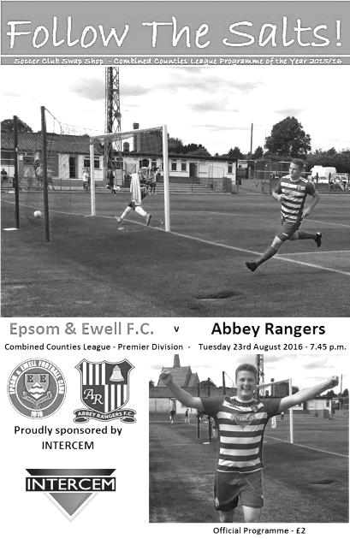

Clinical display of finishing leaves Salts well clear in the end

In recent times we have become quite accustomed to seeing our boys rattle up a big score away from home, but large wins at High Road have been much rarer. Maybe this result, a 7-1 win over first time visitors, the newly promoted Abbey Rangers is a sign of things to come at High Road. It was the first time we had scored seven goals at home since a 1998 7-2 rout of East Thurrock United and this was our largest win at home since that famous night in April 1996 when we defeated Tring Town 11-1. Yes Steve Dyke, you missed it again!

Although we competed well at Faversham Town, we went into this game on the back of three defeats and with a growing injury list. Steps were taken with two new lads joining us in Charlie Clark-Gleave and Matt Price, although both had contrasting evenings as the former hurt his back early in the match and had to go off at half time while the latter, reminiscent of a young Stuart Miller, a hard working striker from twenty years previously, was a constant threat and, like Miller, scored on his debut.

In addition to the new starters Adam Heagney earned his first start at right back ahead of Rhys North, while Reisse Griffin came in at left back for the injured Matt Tanton. Up front, Price came in for the injured Tom Neale, while Agi Panayiotou started on the left in place of Rob Hendry.

But this match report cannot continue without mention of Daryl Cooper-Smith. His second hat trick of the season, taking him to nine goals by the end of August was totally clinical and he set another two up. He got on the score sheet in just the fifth minute after Price was fouled. Sam Robinson curled the free kick in but not to the far post where many were expecting the delivery. Cooper-Smith collected the ball, turned and forced the ball past the advancing Liam Stone in the Abbey goal, earning a whack for his troubles from a defender who was unable to quite get there in time. Fortunately he recovered after treatment as he had a big night ahead of him.

Robinson was not far away with a powerfully struck free kick from 30 yards before Price shot over from a tight near post angle after good work from Griffin and Matt Farrell. However, as the game resumed it was apparent that we weren't controlling the game anymore. The visitors looked good on the ball for a while until Tom Bentley went too far with a high and clearly reckless tackle on Matt Ferdinando in the 21st minute and was given a straight red card, which ironically means he will miss the two teams' next meeting in a fortnight in the League Cup.

Still the dismissal didn't upset the tempo of the visitors who continued to play well and when Griffin went in a little high on a defender just after the half hour, you feared the worst, even

though he had gone into the challenge off balance after being fouled. Indeed that was probably the difference between the two challenges and we had the unusual situation of collecting a yellow card and a free kick at the same time!

Moments later it was 2-0 as Cooper-Smith collected the ball outside the area and drilled the ball into the top right corner of Stone's goal from about 20 yards. Six minutes later we had extended our lead after Heagney had done well on the right flank and laid the ball up for Griffin to deliver. Cooper-Smith met the ball at the far post, heading it across for Ferdinando to drill into the bottom corner from 12 yards. Six minutes later Cooper-Smith turned provider again as his pass put Price in the clear and he rounded the keeper and scored our fourth in the 44th minute.

This was incredibly harsh on our visitors as possession had been fairly even in the first half. However, Epsom supporters will be well aware that we can hit these purple patches and we had just witnessed another. The big question here was how many we would end up with. Two substitutions were made at the half with Craig Hastings coming on for the unfortunate Clark-Gleave and Jordan Gallagher replaced the once again limping Ferdinando.

Gallagher would have an impressive half and with his first pass he split the defenders and let Panayiotou in on the right but he hesitated, cut back in a closing defender and by the time he struck at goal he found his way blocked. Pressure was building though and Farrell and Robinson had half chances before Price set up Cooper-Smith who slammed home his third and our fifth goal to Stone's left from the edge of the box in the 57th minute. Six minutes later Gallagher blazed over after being set up for an easy finish by Cooper-Smith but it was 6-0 within a minute anyway as players were queueing up to finish; this time Farrell got there ahead of Cooper-Smith to drill home.

Four minutes later the visitors had a goal as Patrick Ruzicki robbed Ali Turpie and rolled the ball into the vacant net. In the 75th minute they struck a free kick out for a goal kick off our crossbar and Turpie was forced into a fine low save from a corner just after this. We then went straight down the other end and when Robinson set up Price with a great back flick, he smashed the ball at Stone from just ten yards and while the ball was well blocked it fell to Gallagher who this time made sure by rolling the ball into the empty net.

We had a strange situation in injury time when Robinson was fouled in the act of turning his man, but the ball fell to Griffin whose shot was blocked to substitute Hendry who hit the post from a narrow angle. However, once the danger had passed it was clear that we should have had a penalty in the first place!

Still, our exciting season continues and after six games we have scored 24 goals but conceded 14. We have scored in all six but have also conceded in all six. If we can sort out the defensive issues we will be a threat. As for Abbey, there may have been a bit of naive defending at times but they kept going and we would be very wrong to assume that a similar result will occur in a fortnight when we meet again.

Epsom and Ewell: Alistair Turpie, Adam Heagney, Reisse Griffin, James Taylor,
Charlie Clark-Gleave, Sam Robinson, Savvas 'Agi' Panayiotou, Matt Farrell (c),
Matt Price, Daryl Cooper-Smith, Matt Ferdinando

Subs: Craig Hastings for Clark-Gleave (46), Jordan Gallagher for Ferdinando (46),
Rob Hendry for Cooper-Smith (71)

Club Records - 29th August
Date | Day | Competition |  | Opponents |  | Scorers
29/08/31 | Sat | Friendly | H | Godalming | 6-0 | T.Jones (2), o.g., T.Winship, T.Dunne, W.Graham
29/08/36 | Sat | London League | H | West Norwood | 3-3 | J.Jones (2, 1 pen), T.Dunne
29/08/53 | Sat | Corinthian League | H | Maidenhead United | 0-2
29/08/59 | Sat | Corinthian League | A | Slough Town | 2-3 | J.Bangs, J.Sorensen
29/08/62 | Wed | Corinthian League | H | Erith & Belvedere | 0-2
29/08/64 | Sat | Athenian League 1 | H | Chesham United | 0-3
29/08/66 | Mon | Athenian League 2 | A | Rainham Town | 2-2 | T.Sackett, G.Boulter
29/08/70 | Sat | Athenian League Cup 1 | H | Carshalton Athletic | 0-1
29/08/81 | Sat | Isthmian League 1 | H | Hertford Town | 2-1 | J.Hunn (pen), M.Francis
29/08/83 | Mon | Isthmian League Cup 1 | A | Tooting & Mitcham United | 1-3 | S.Milton
29/08/87 | Sat | F.A. Cup Preliminary Round | H | Arundel | 4-0 | C.Gartell, B.Perkins, G.Greenaway, A.Mair
29/08/89 | Tue | Isthmian League Cup Preliminary Round | H | Collier Row | 1-1 | C.Hadingham
29/08/92 | Sat | F.A. Cup Preliminary Round | A | Deal Town | 0-3
29/08/98 | Sat | Isthmian League 3 | A | Croydon Athletic | 3-2 | J.Tome (2), T.Boorman
29/08/00 | Tue | Isthmian League Cup Preliminary Round | A | Leighton Town | 2-1 | J.Hall, L.Dooley
29/08/09 | Sat | F.A. Cup Preliminary Round | A | Selsey | 0-1
29/08/11 | Mon | Combined Counties  Premier Division | A | Raynes Park Vale | 2-3 | J.Summers, R.Burns
Historical Decades
Date | Day | Competition |  | Opponents |  | Scorers
90 years ago – Epsom Town F.C.
28/08/26 | Sat | Friendly | H | Millwall United | 4-3 | R.Marlow (2), J.Parr, W.Challis
80 years ago – Epsom F.C.
29/08/36 | Sat | London League | H | West Norwood | 3-3 | J.Jones (2, 1 pen), T.Dunne
70 years ago – Epsom F.C.
31/08/46 | Sat | London League | H | P.O.Engineers | 5-1 | D.Ralph (4), K.Holliday
60 years ago – Epsom F.C.
01/09/56 | Sat | Corinthian League | A | Uxbridge | 1-0 | J.Sorensen
50 years ago – Epsom & Ewell F.C.
29/08/66 | Mon | Athenian League 2 | A | Rainham Town | 2-2 | T.Sackett, G.Boulter
40 years ago – Epsom & Ewell F.C.
30/08/76 | Mon | Athenian League 1 | A | Marlow | 2-0 | M.Peters, J.Eales
30 years ago – Epsom & Ewell F.C.
30/08/86 | Sat | F.A. Cup Preliminary Round | H | Three Bridges | 1-2 | M.Elliott
20 years ago – Epsom & Ewell F.C.
28/08/96 | Wed | Isthmian League Cup Preliminary Round | H | Wivenhoe Town | 3-2 | S.Miller (2), A.Boxall
10 years ago – Epsom & Ewell F.C.
28/08/06 | Mon | Combined Counties  Premier Division | A | Chessington & Hook United | 1-1 | P.N'gbale

History Corner – 29th August
85 years ago today we opened up a new season with our first competitive match, a friendly against Surrey Senior League Godalming which we won 6-0. This was a big season for our club, having drifted for a few years since winning the London League in 1928. We would start to see a few new faces this year, with six players making their debut this day. One of these was Tommy ‘Tot’ Winship who had moved south from the North East in search of work. Built like the proverbial outhouse but small in height, hence the nickname, he didn’t score many goals; just 5 in 171 appearances, but he got one this day. From conversation with a former long term helper at the club Wilf Smith, I learned that Winship worked in the Epsom Hospitals and was in fact killed by a patient, but I have as yet no further evidence to support this story.

W.Graham was another who scored on his debut, while far more importantly the third player to score on his debut was Tommy Dunne. Dunne was a Welshman who also came to Epsom looking for work and has a very rare place in our history as the only player to ever become an Amateur International while at our club. He would also go on to play for Wimbledon but made many appearances for us as did another who would join in a week or two, Bobby Gill. We had quite a side and would finish runners-up behind unbeaten Park Royal, not to mention a place in the last 32 of the Amateur Cup after defeating Ipswich Town on their own patch! The Thirties was quite a good time to be a supporter!

70 years ago this week we opened up our season with a 5-1 London League win over our local rivals the Post Office Engineers. Don Ralph set a club record still unmatched with four goals on his debut and Ken Holliday scored the other one.

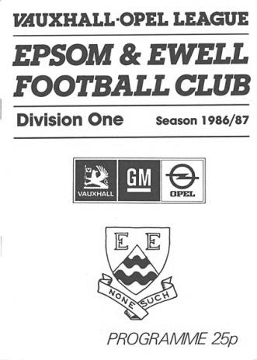
30 years ago today future Leicester City and Scotland international Matt Elliott scored his first goal for our club, although his equaliser ultimately counted for nothing as Three Bridges put us out of the F.A. Cup at West Street by two goals to one. (see programme)

7 years ago today we conceded to a wind assisted fluke as we were knocked out of the F.A. Cup by ten man Selsey. The less said about that, the better!

EL Records Premier Challenge Cup
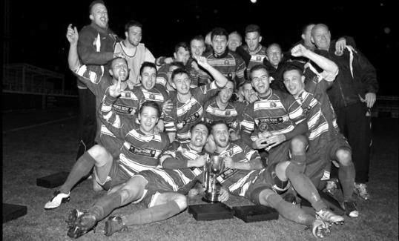
First Round
Redhill | 6/9 | Bedfont & Feltham
Spelthorne Sports | 13/9 | Sutton Common Rovers
Knaphill | 9/9 | Camberley Town
Worcester Park | 24/9 | Dorking
Epsom & Ewell | 6/9 | Abbey Rangers
Westfield | 6/9 | North Greenford United
Cobham | 6/9 | Bagshot
CB Hounslow United | 6/9 | Farnham Town
South Park Reserves | 14/9 | Balham
Second Round
Hanworth Villa | 4/10 | 5
AFC Hayes | 4/10 | 9
Epsom Athletic | 28/9 | Windsor
2 | V | Bedfont Sports
Raynes Park Vale | 4/10 | Colliers Wood United
Frimley Green | 4/10 | Banstead Athletic
6 | 4/10 | 1
Staines Lammas | 15/10 | 8
4 | V | Cove
Badshot Lea | 4/10 | Guildford City
Chertsey Town | 4/10 | 3
7 | V | Chessington & Hook United
Hartley Wintney | 4/10 | AC London
Horley Town | 4/10 | Sheerwater
Walton & Hersham | 4/10 | Eversley & California
Ash United | 11/10 | Farleigh Rovers

Surrey Senior Cup
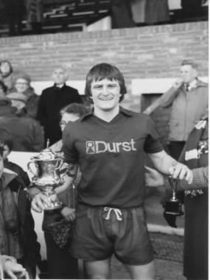
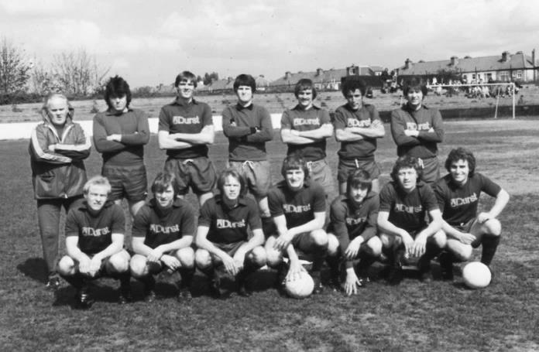
First Round
Abbey Rangers | V | AFC Croydon Athletic
Whyteleafe | V | Westfield
Second Round
Kingstonian | V | Met Police
Ashford Town (Mx) | V | Knaphill
Woking | V | Walton Casuals
2 | V | Colliers Wood United
Guildford City | V | Horley Town
Egham Town | V | Corinthian Casuals
Godalming Town | V | Merstham
Molesey | V | Leatherhead
Raynes Park Vale | V | Sutton United
Sutton Common Rovers | V | Camberley Town
Dorking Wanderers | V | South Park
Badshot Lea | V | Farnham Town
Walton & Hersham | V | Croydon
Carshalton Athletic | V | Tooting & Mitcham United
Chertsey Town | V | 1
Epsom & Ewell | V | Chipstead

Centre page for results

Centre page for results

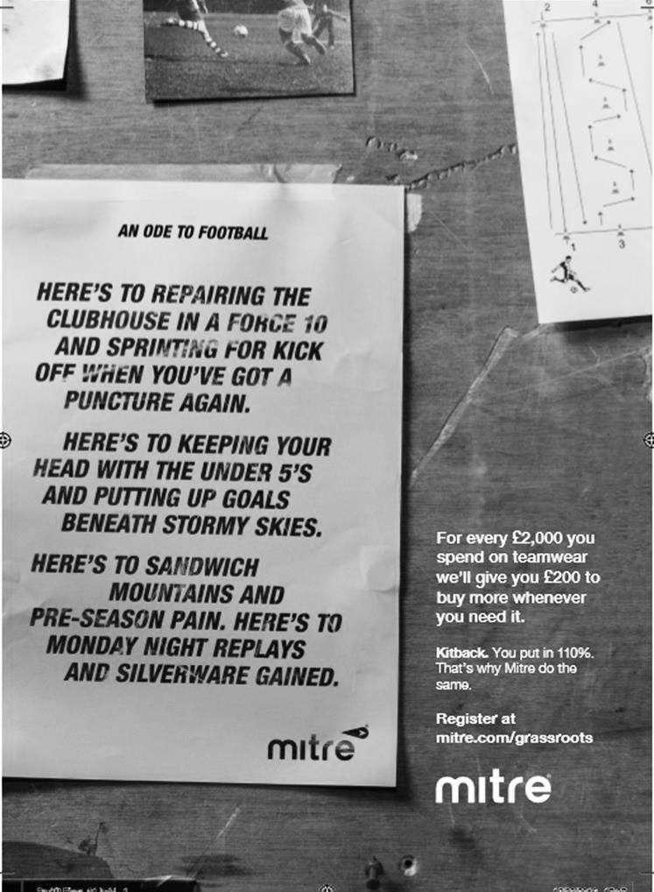

Horley Town – History
Horley Football Club was first affiliated to Surrey County FA in 1896. In 1903 another local club by the name of Gatwick Rovers was formed and the two clubs merged in 1908 with Horley retaining its name. Both these original clubs played in the same colours of red and black and it was not until 1912 that Horley adopted the colours of claret and blue that they still wear to this very day.Intermediate football was tasted for the first time in season 1925/26 following an appearance in the Surrey County Junior Cup Final in 1923/24 and winning the Surrey County Junior Charity Cup in 1924/25.

Post-war Era

Following the Second World War, Horley was faced with the prospect of losing its home at “The Kings Head” ground and set about finding a new home. A local landowner by the name of Major A.L.N. Jennings became the Club’s benefactor (and President) following his generous decision to give the club 10.7 acres of land in Smallfield Road. The land was held in trust for the people of Horley from 1947, in memory of those that died in the defence of their country, and the ground was appropriately named “The Defence”.Season 1950/51 saw Horley win the Surrey Intermediate League Eastern Section and seek election to the Surrey Senior League for season 1951/52. This excursion into Senior football was short lived as the Club found themselves back in Junior football by season 1954/55. Intermediate status was regained in 1956/57 season and in season 1957/58 they entered their first ever Youth team in the local Redhill & District League.

The Seventies

With the expansion of the village of Horley to a town the Club changed its name in 1974 to become Horley Town F.C. During this spell in senior football, Horley Town enjoyed their most successful period culminating in the winning of the Surrey Senior League title and Surrey Senior League Challenge Cup in 1976/77. The Club also reached the final of the Surrey Senior League Charity Cup in this season.

The club went on to compete in the London Spartan League and the Athenian League before returning to the Combined Counties League (formerly the Surrey Senior League).

The Modern Era

The early 1980’s saw the Club expand their interest in Youth football with the creation of Horley Town Minors. This relationship has grown over the years and is the reason why the Club has evolved into a well respected “community club” providing football for the people of Horley irrespective of age, sex or race.In September 2003, Horley Town moved to their new ground, named “The New Defence” in deference to their old home, behind the Horley Adult Education Centre, which has now been demolished and replaced by the new Horley Leisure Centre.

The Club has been in the Combined Counties League Premier Division since 2006 and, in addition to its Reserves and Youth teams, incorporates successful junior football teams at all age levels.
In 2009/10 the Club welcomed Horley Rugby Club, and The New Defence Sports Club with its excellent facilities can now offer both sports to local enthusiasts on a regular basis.

2013/14 saw Horley Town FC appoint Ex player and club stalwart defender Anthony Jupp as manager alongside former player Chris Weller. Last season the Club had a very successful season finishing 6th in the League the highest position for years and the most ever points. The Club also had the league Top goal scorer Ashley Nadesan who scored 99 goals in the last two seasons before signing form League One side Fleetwood Town in a three year professional contract.

Today’s match – In memory of Chris Henry
On Tuesday July 13th 2004, the club lost one of its long-term supporters at the tragically young age of 46.

Chris Henry was well known to anyone that regularly attended Epsom matches in the past. He once told me that his first game was a 0-0 draw against Marlow at West Street on 25th January 1969, when he was only 11 years of age.

In those days, a 0-0 draw was looked on as a positive result, as the team was to go through some very dark days before its resurgence and subsequent Wembley appearance in 1975.

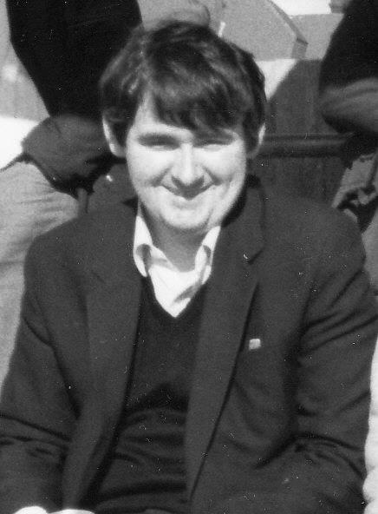
However, Chris stuck with it, supporting the club home and away throughout those bad times. Although there are older supporters who have seen the club play from an earlier date, there was no one else in my opinion that had seen as many games at the time as Chris had; only missing four or five a season on average at most during his long association with the club. He probably reached two thousand games if you include Reserve and Youth matches, of which he saw many.

I first met Chris in 1982. Both myself and John Steinmetz had started to attend some of the away games in our first season watching the club. Standing behind the goal at Wembley F.C. on 27th February 1982 we met up with Chris and Gary Vickers, and started to attend as many games as possible with them, usually taking a football with us. John, Gary and I would kick around in a nearby park, while Chris sat there watching and listening to his radio!

He may sometimes have come across to those who didn’t know him as a quiet individual, but once you could get him talking about music or football in particular, he was a changed person and would be much happier. He is in a happier place now, and we all still miss him, particularly at times like today when the game is sponsored in his memory.

Our thoughts also go to his sister Mary and his brother Ray and family, all of whom have been regular visitors and match sponsors over the years.

Every Opponent A-Z
Over the years we have played many, many different opponents. Exactly how many is a difficult question, as it all depends on your definition. Are Camberley & Yorktown different to Camberley Town, or are Epsom Town different to Epsom F.C. or Epsom & Ewell F.C.?

In my analysis I have classed them as the same team, and will work through them all from A to Z. Some we have played many times, whilst others we have met just once or twice. Enjoy!

Stamford: Played 2 - W1 D1 L0 - F2 A1 - PPG - 2.00 - Very Good
Stamford are inextricably linked with our run to Wembley Stadium in the inaugural F.A. Vase in 1975. Paired together in the two-legged Semi-Finals, the United Counties League team were seen as favourites for the entire competition, but had to visit us first on 22nd March 1975 in front of 1,604 spectators at West Street.

We trailed at the half, but fought back to equalise through Trevor Lee and then Phil Walker struck the winning goal (see below) to give us the advantage for the return in Lincolnshire.

The return leg just seven days later remains the furthest North our club has ever travelled and at the time was the furthest we had ever travelled in any direction, but many supporters made the journey to Wothorpe Road to take their place amongst a 2,500 crowd that was tense and edgy. Ultimately our boys held on for a goalless draw and we were going to Wembley Stadium for our memorable Final against Hoddesdon Town.

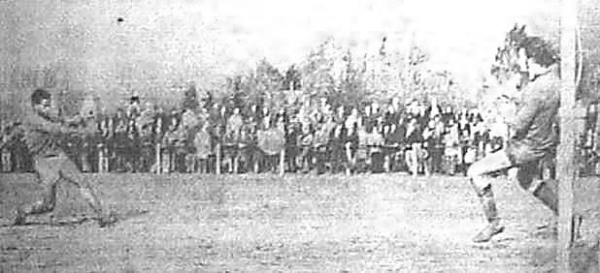
We never met Stamford again, but they had success themselves, visiting Wembley in the Vase on three occasions in the same competition. They would get there in 1975/76, narrowly losing to Billericay Town and they were also unfortunate to lose 3-2 to Stansted in 1984 but their crowning moment came in 1980 when they won the Vase 2-0 over Guisborough Town.

In the last couple of seasons Stamford have vacated their old ground for a shiny new complex a little out of town, but to be fair, they probably needed to as they now play at Step Three in the Northern Premier League, with regular opponents like Blyth Spartans, Workington and Whitby Town!

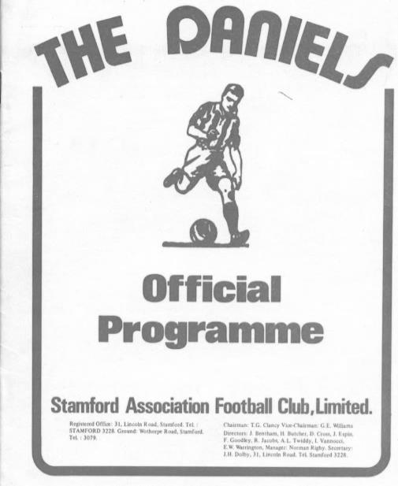
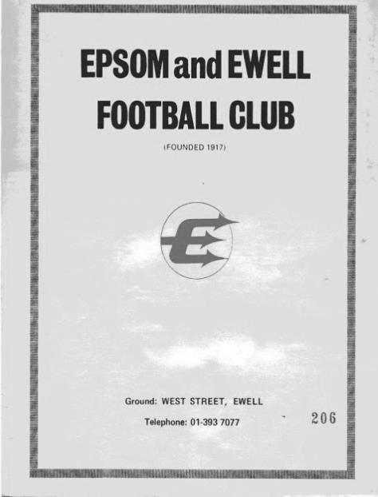
Above: our two F.A. Vase Semi-Final programmes

Stansted: Played 2 - W1 D1 L0 - F6 A1 - PPG - 2.00 - Very Good

I referred to Stansted in the above section as Vase winners in 1984 and on Saturday 7th November 1998 we were paired in the First Round of the F.A. Vase at Merland Rise for the first time. I was actually missing this game and was in Blackpool with no easy way of finding out the result and had to wait until picking up a Sunday paper to find that we had lost 4-2.

But we hadn’t! It was an error repeated across the Press agencies. I only found this out on the Monday when fellow long-serving supporter Steve Davies asked me what time I was leaving for the replay! It transpired that we had actually drawn 1-1 after extra time, and were leading with moments left before a keeper error had forced extra time, through which there was no score.

A Vase match at a new ground. Fantastic! And it got even better when we defeated them 5-0 on their own ground just three days later, with Martin Jones smashing in his only hat trick for the club.

The Vase dream ended in the next round when a late and harsh penalty ensured that we fell to a 2-1 defeat in deepest Norfolk at Fakenham Town. Stansted remain in the Essex Senior League at Step Five.

Stevenage Borough / Stevenage: Held over to next issue

Steyning Town: Played 1 - W1 D0 L0 - F3 A0 - PPG - 3.00 - Perfect

We have only visited The Shooting Field on one occasion, when drawn there for an F.A. Vase Preliminary Round tie on 5th October 1991. The first half was close and goalless but we ran away with it to record a 3-0 win in the end with goals from Mark Pepper, Graham Morris and Russell Green.

Steyning are not one of Sussex’s great achievers. Many clubs have at least had a few seasons where they looked good before falling back to local league normality but they haven’t even achieved this, and currently reside at Step Six in the newly named Southern Combination Division One.

Player Sponsorship
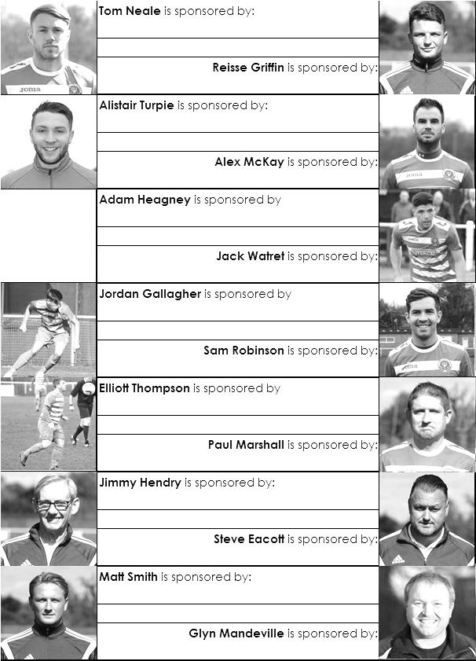

Here is the opening list for the 2016/17 season showing all of our players and Management that are currently available for sponsorship.

Sponsorship costs just £40 and it is easy to do. Just select a player who has not been previously sponsored and let a Committee Member know that you would like to sponsor them. Beware though. Until we have received the money it is possible for someone to jump in front of you, so don’t delay, sponsor today!
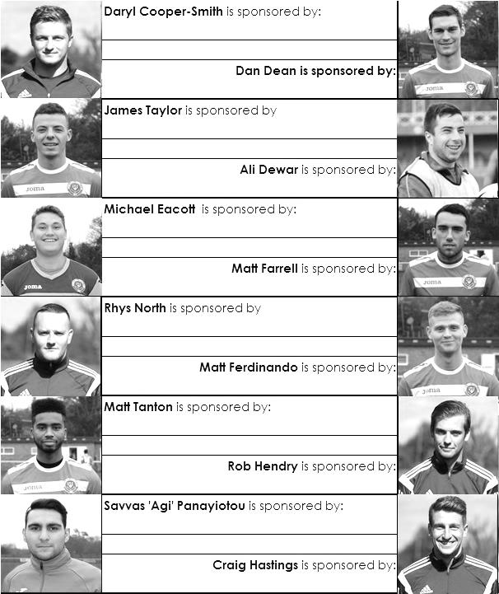

Match and Ball Sponsorships – 2016/17
Opponent | Date | Match Sponsor | Ball Sponsor
Gravesham Borough | 07/08/16 | Club President - Stella Lamont
Gravesham Borough | 07/08/16 | Relocation Committee Member - Mike Lovett
CB Hounslow United | 16/08/16 | EEFC Management Committee
Abbey Rangers | 23/08/16 | Steve & Geoff Dyke
Horley Town (11.30am) | 29/08/16 | In Memory of Chris Henry
Abbey Rangers (LC) | 06/09/16
Camberley Town | 10/09/16
Guildford City | 13/09/16
Knaphill | 24/09/16
Sutton Common Rovers | 08/11/15
Windsor | 15/11/16
Bedfont Sports | 19/11/16
AFC Hayes | 26/11/16
Hanworth Villa | 13/12/16
Chertsey Town | 17/12/16
Raynes Park Vale (11.30am) | 27/12/16
Spelthorne Sports | 07/01/17
Bedfont & Feltham | 21/01/17 | Programme Editor - Richard Lambert
Badshot Lea | 04/02/17
Westfield | 18/02/17
Walton & Hersham | 04/03/17
Hartley Wintney | 18/03/17
Farnham Town | 25/03/17
Colliers Wood United (1.00pm) | 14/04/17 | Good Friday match – make a note!
North Greenford United | 22/04/17
 | tba | F.A. Vase – if drawn at home
Chipstead (SSC) | tba
For League, League Cup and Surrey Senior Cup Matches:
Match sponsorship - £40.00 Match ball sponsorship - £25.00. Combined £55.00.
For F.A. Cup and F.A. Vase matches:
Match sponsorship - £50.00 Match ball sponsorship - £30.00. Combined £65.00.

Sponsorship includes: (x2 for match, x3 for match and ball)

Admission, programmes, hospitality and advertising and mascot for the day (if required).
If you are interested, just speak to a Committee Member, or drop me an email at: richard.c.lambert@gmail.com

We also thank our Kit Sponsors INTERCEM

Salts Super Six Predictor
The Salts Super Six Predictor is live again for today’s match and the tickets are on sale at today’s game to the left of the gate.

The competition is easy to play and you don’t even have to be at the match! To win, you simply need to predict the results of six matches correctly from the three options, fill in the form and make sure it is back with one of our distributors before the deadline on the ticket. The latest fixtures are shown here and are a bit of a mixed bag to be honest!

If you are a club regular, you just need to place your name on the sheet, although if you aren’t, then we’ll need a contact number from you too. We will announce any winners on the website within three working days, so don’t worry, we won’t miss you!

We had a big jackpot winner last year and who knows how much could be won this time! It is currently £117 and you’ll always know the size of the pot before you enter.

Please note that if there is more than one winner, the prize pot would be shared between the winners. All you need to do now is have a go, as many times as you like!

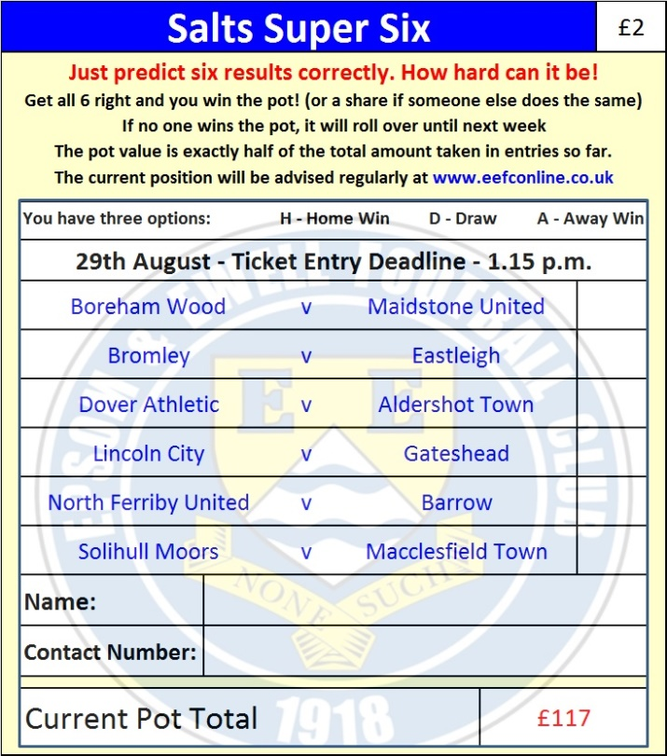

Good luck!

Combined Counties League – Premier Division
Monday, 29th August 2016 - Kick-off 11.30 a.m.
Epsom and Ewell  (Royal Blue & White hoops) | V |  | Horley Town  (White & Black/White/White)
Squad | NUMBERS
Michael Eacott |  |  | George Hyde
James Taylor |  |  | George Branton
Matt Tanton |  |  | Craig Peckham
© Dan Dean |  |  | Scott Robson
Craig Hastings |  |  | Ryan Brackpool
Sam Robinson |  |  | Adam Pullin ©
Rob Hendry |  |  | Liam Cox
Matt Farrell |  |  | Lewis Forsdick
Daryl Cooper-Smith |  |  | Jack Poplett
Matt Ferdinando |  |  | Ben Herdman
Reisse Griffin |  |  | Alex Barbary
Savvas ‘Agi’ Panayiotou |  |  | Liam Giles
Rhys North |  |  | Luke Ragetti
Alex McKay |  |  | Robert Burbidge
Jordan Gallagher |  |  | Connor Power
Charlie Clark-Gleave |  |  | Jack Tomlin
Alistair Turpie |  |  | Kyle Hough
Matt Price |  |  | Tate Greenaway
Adam Heagney |  |  | Leyton Regan
Manu Sale |  |  | Richard Wetton
Glyn Mandeville | MANAGER |  | Anthony Jupp
Matt Smith | ASSISTANT
Steve Eacott / Alex McKay / Jimmy Hendry | COACHES / PHYSIO |  | Chris Weller / Matt Chapman / Alan Rogers / Gail Selby
REFEREE: T.Dowdeswell
ASSISTANTS: R.Brown, R.Wells
Today’s Match and Match Ball are sponsored
in memory of long-serving supporter Chris Henry

OUR NEXT VISITORS TO HIGH ROAD
Abbey Rangers
Combined Counties League Cup – First Round
Tuesday 6th September 2016 – 7.45 p.m.

